Dear Mentor,
As part of our career pathing initiative for our team members, we have created the MVP School for Veterinary Professionals. Although our program is currently unaccredited, we are actively pursuing accreditation to offer an associate in applied science degree in Veterinary Technology. This schooling allows our students to work full-time while attending classes.
_______________________________, a team member at your hospital, has shown interest in joining the program and is asking for your support and commitment as part of the application process. We know that the most successful students have strong mentors. As part of the application process, we are requiring our applicants to bring forward a self-appointed mentor who is willing to commit to supporting the student educationally and emotionally through the program.
A mentor can be either a licensed veterinarian or a credentialed veterinary technician, depending on which individual is the best fit for the student. As a mentor, you serve as the student’s primary point of contact in the hospital, guiding and overseeing their progress through the program.
The school currently offers a 6-quarter diploma program and has also developed an 8-quarter associate degree program, both structured in 10-week quarters. The associate degree track has been designed with the credits and courses required to be submitted for institutional and AVMA accreditation. If those approvals are granted, the associate degree program is designed so that graduates may be able to pursue eligibility to sit for the Veterinary Technician National Examination (VTNE), depending on the requirements of the state in which they are enrolled.
It is the school’s intent, once accreditation is achieved, to provide a pathway for diploma students to transition into the degree program. While this outcome cannot be guaranteed, it reflects the institution’s commitment to expanding opportunities for graduates as approvals are secured.
It will be your responsibility to work with the student and to make sure that they are hitting their benchmarks.
Part of the program also requires skills-based assessments. These skills will need to be demonstrated at the practice level and will need to be documented and signed off on. These skills assessment activities are a vital part of the program, and the student cannot progress without demonstrating the necessary skills. By agreeing to be a mentor, you are committing to assisting the student in getting exposure to the experiences necessary for them to work on their skills. They not only need to demonstrate their skills, but for the benefit of your hospital, master them and show proficiency in them. You will be the point person for signing off on their skills set list.
We are committed to supporting you as a mentor. We want you and your student to be successful in your roles. There will be a mentor orientation closer to the start date of the program and you will receive an invite to attend this meeting. Please feel free to reach out to

We are pleased to be able to offer a bonus opportunity for those mentors with a mentee in the MVP School for Vet Professionals. Bonus is paid on a quarterly basis. The expectations of our mentors are as follows:
- Attend Monthly mentorship meeting in Mpower
- Meet with your mentee weekly to discuss progress and roadblocks
- Submit a weekly meeting report (survey link provided)
- Complete the mentor content assigned in Mpower
- Help with skill development
- Provide sign-off on technical skills (training provided)
- Celebrate all the wins along the way!

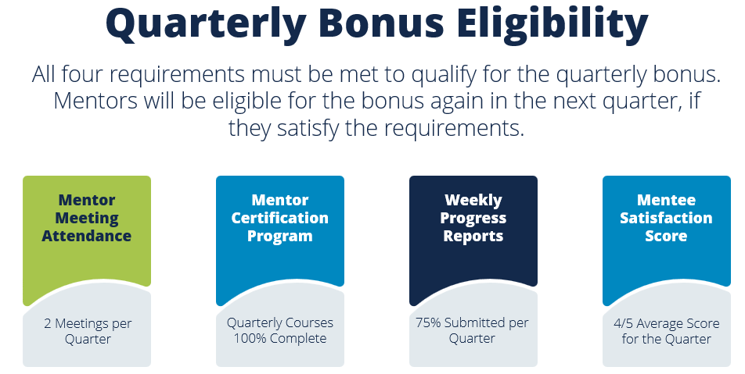

VTMentorship@mvetpartners.com or submit a FreshService ticket with any questions regarding the mentorship program.
If you are in agreement with the details and responsibilities laid out in this document, please sign below.
__________________________________________________
Signature
____________
Date

